**Explain how Neo4j is used for managing the social network data.**

**What is Neo4j?**

* Neo4j is a powerful, high-performance, open-source [graph database](https://www.geeksforgeeks.org/what-is-graph-database/) that enables the efficient management and querying of highly connected data.
* It stores data in the form of **nodes** (things) and **relationships** (connections between those things). This is different from traditional databases that store data in rows and tables.
* It is suited for applications involving complex relationships and dynamic, interconnected data.
* In a social network like Facebook, Instagram, or LinkedIn, people are connected to other people (friends, followers, or contacts), and those connections can have types (like, comment, follow, tag). Neo4j can naturally represent and manage all these connections efficiently.

**Why Use Neo4j for Social Network Data?**

* A **social network** is all about **people (users)** and their **connections (friends, followers, likes, comments, etc.)**.
* These relationships are **very important** and **highly connected**, which can become complex to manage with traditional databases.
* Neo4j is designed **exactly for this kind of data** — it stores and explores relationships efficiently, making it perfect for modeling social networks.

**What is a Graph Database?**

A graph database uses graph theory to store, map, and query relationships. It consists of nodes, edges, and properties, where:

* **Nodes** represent entities such as people, businesses, or any data item.
* **Edges** (or relationships) connect nodes and illustrate how entities are related.
* **Properties** provide additional information about nodes and relationships.

**Neo4j structure**

* Neo4j stores and present the data in the form of graph not in tabular format or not in a Json format.
* Here the whole data is represented by nodes and there you can create a relationship between nodes.
* That means the whole database collection will look like a graph; that’s why it is making it unique from other database management system.

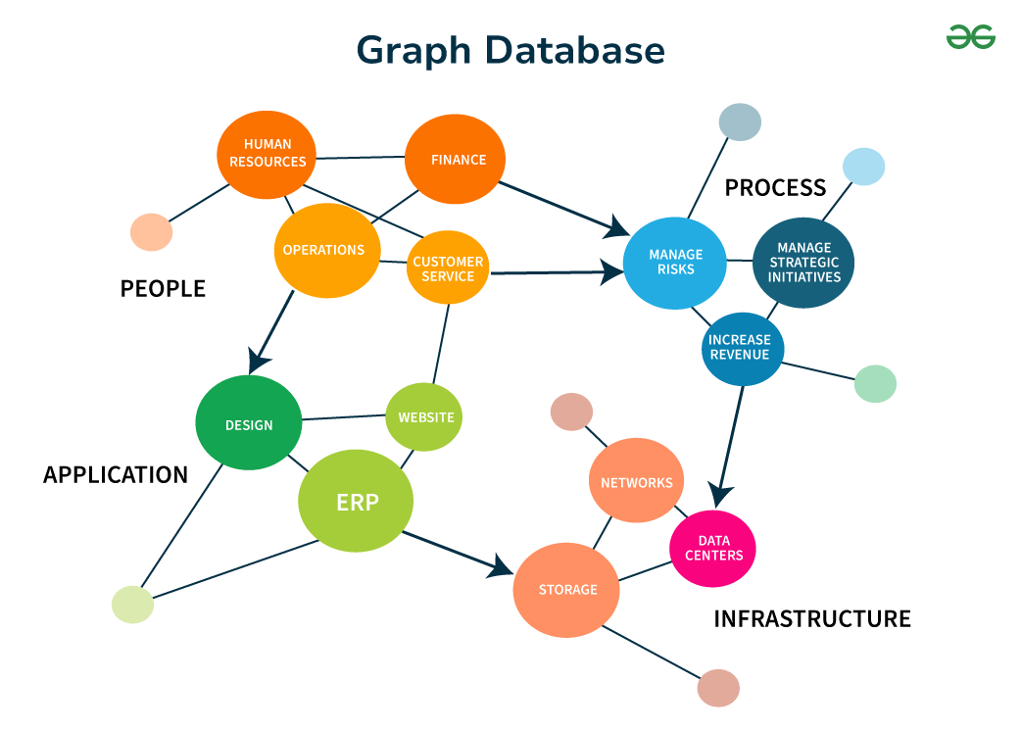

**How Social Network Data Works?**

In a social network, there are **users** (like you and your friends), and they interact with each other in various ways:

* They **add friends**
* They **send messages**
* They **like or comment** on posts
* They **follow** each other
* They **tag** others in photos
* They **join groups**

Each of these actions creates **relationships** between users or between users and content. Traditional databases can represent this using many separate tables and complex JOIN operations, which becomes slow as the data grows. Neo4j, on the other hand, handles this naturally and much faster because of its graph structure.

**Components Used in Neo4j for Social Networks**

**1. Nodes – These are the entities in the network. Examples include:**

* User (a person)
* Post (a message or photo)
* Group (a community)
* Page (a business or interest)
* Comment (feedback on a post)

Each node has properties like:

User:

name: "John"

age: 22

city: "Chennai"

**2. Relationships – These are connections between nodes. Examples:**

* FRIENDS_WITH (between two users)
* LIKES (user likes a post)
* FOLLOWS (user follows a page)
* COMMENTED_ON (user commented on a post)

Each relationship can also have properties. For example:

**John -[FRIENDS_WITH {since: 2023}]-> Arjun**

**3. Cypher Query Language –** Neo4j uses a special language called Cypher to create and query nodes and relationships. It is simple and powerful for social networks.

Example:

MATCH (a:User)-[:FRIENDS_WITH]->(b:User)

WHERE a.name = "John"

RETURN b.name

This returns all friends of John.

**Using Neo4j for Social Network Data:**

**Step 1: Store People and Their Actions as a Graph**

Neo4j uses a **graph structure**, which means:

* Each **person** is stored as a **node** (like a circle).
* Their **posts**, **likes**, **comments**, and **friendships** are also nodes or relationships (like arrows between circles).

Example:

* A user named John becomes a User node.
* If John posts a status, it becomes a Post node.
* If he likes someone’s post, a LIKES arrow connects him to the post.
* If he’s friends with Arjun, a FRIENDS_WITH arrow connects them.

So, in Neo4j:

* People = **Nodes**
* Actions/Connections = **Relationships**

**Step 2: Use Cypher Queries to Analyze and Use the Data**

* Get a person’s **friends**
* Suggest **mutual friends**
* Show all **posts** by a user
* Find who **liked or commented** on a post

Example Query: Show John’s friends

MATCH (u:User {name: "John"})-[:FRIENDS_WITH]->(f:User)

RETURN f.name

Example Query: Show posts liked by John

MATCH (u:User {name: "John"})-[:LIKES]->(p:Post)

RETURN p.content

These queries are fast and easy, even for **complex networks** with millions of users.

**Benefits of Using Neo4j for Social Networks**

1. Social networks are all about connections. Neo4j’s graph model is a natural fit.
2. Neo4j is much faster at finding connections like mutual friends or shortest paths between users.
3. It works well even when you have millions of users and relationships.
4. You can easily add new types of nodes and relationships without redesigning the database.
5. Great for real-time friend suggestions, content recommendations.

**Challenges in Using Neo4j**

* It may be harder to integrate with traditional systems that use relational databases.
* Requires learning Cypher, which is different from SQL.
* For very large-scale networks (like Facebook), graph databases need high-performance hardware and optimization.